PRN : 25070521137

Experiment 14
14.1.1 Complex Number Addition using Class
Algorithm :
Step 1: Start
Step 2: Define class Complex with three methods:
- initComplex(self)
- sum(self, c1, c2)
- display(self)
Step 3: Method initComplex(self)
  - Read two integers from input
  - Assign first value to self.real
  - Assign second value to self.img Step 4: Method sum(self, c1, c2)
  - Set self.real = c1.real + c2.real
  - Set self.img = c1.img + c2.img Step 5: Method display(self)
  - If self.img >= 0:
Print self.real + self.img i
  - Else:
Print self.real - |self.img| i Step 6: Create three objects
  - c1 = Complex()
  - c2 = Complex()
  - c3 = Complex() Step 7: Initialize c1 and c2
  - Call c1.initComplex()
Read and assign real and img for c1
  - Call c2.initComplex()
Read and assign real and img for c2 Step 8: Compute sum
  - Call c3.sum(c1, c2)
  - c3.real = c1.real + c2.real
  - c3.img = c1.img + c2.img

Step 6: Display result
  - Call c3.display()
  - If c3.img >= 0:
Print c3.real + c3.img i
  - Else:
Print c3.real - |c3.img| i Step 10: Stop

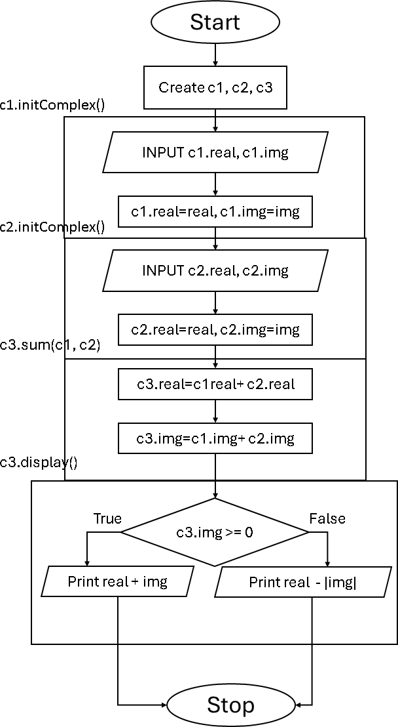
Flowchart :

Code :
class Complex:
def initComplex(self):

PRN : 25070521137
self.real , self.img = map(int,input().split())

def sum(self,c1,c2): self.real = c1.real + c2.real self.img = c1.img + c2.img

def display(self):
if self.img >= 0: print(f"{self.real} + {self.img}i") else:
print(f"{self.real} - {abs(self.img)}i")
# Create three instances
c1 = Complex() c2 = Complex() c3 = Complex()

# Initialize two complex numbers c1.initComplex() c2.initComplex()

# Compute and display sum
c3.sum(c1, c2)
c3.display()
Execution :
